Dear Parents/Guardians,

As an extra activity this year, Mme Youck and Mme Therrien will be taking both classes skating at the Balfour on Wednesday, January 27th from 1:00 to 3:00 and again on Wednesday, February 3rd from 1:00 to 3:00.

As there is no subsidized bussing available for skating, the cost per student is $3.00. The money and the permission form need to be returned to the school by Friday, January 22nd. No late forms will be accepted.

We will not be allowing the students to play hockey or broomball. So while helmets are strongly encouraged, they are not mandatory as per the School Board’s Physical Education Safety Guidelines. All students who are coming to the rink are expected to have skates, come properly dressed and to show sportsmanship on the ice.

Students are expected to be on their best behaviour at all times. As they are representatives of our school, any inappropriate language or actions will result in a loss of that student’s future outdoor education privileges. Parents will be informed if this does occur.
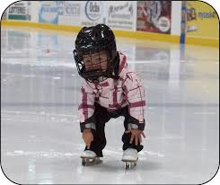
We are looking forward to great afternoons skating!

Yours in education,

Mme Youck and Mme Therrien

_________________________________________________________________________________________________

I give ______________________________________ permission to go skating at the Balfour on Jan. 27th and Feb.3rd.

I have enclosed $6.00 ____ cash, $6.00 ______ cheque or $6.00_______ KEV online payment to cover bussing.

__________________________________________________
(Signature of Parent/Guardian)

